Linux commands:

**Vi filename** - creates the file with that name

1. Press insert
2. Then type as normal
3. After finished press escape
4. Then to :w, to write and :wq to write and quit

When trying to run this file it wont work as it was not given access

To give access we use

**Chmod +x** filename

Means to change mode

1. +x or 0766 means anyone
2. 0700 means only owner
3. Ls -1 script.sh *to see what the permission is*

Or we can say *bash script.sh*

**We can comment** using #message

And multiple line commenting using <<COMENT1 msg COMMENT1

**debugging**

Bash -x can be used to check the script’s code for debugging

*These below must be written into shell*

Set -x displays commands as they are executed

Set - v displays only the inputs

Set -n only reads the code but does not execute

**Say we want to wait for an input**

echo "press any key"

while true; do

read -rsn1 key

if [[ -n "$key" ]]; then

echo "terminated"

break

fi

Done

If we want to store that input

*read( -t number* ***for a timer not needed****)-p "Enter your name : " name*

*echo "Hi, $name. Let us be friends!"*

**Shell contains many variables**

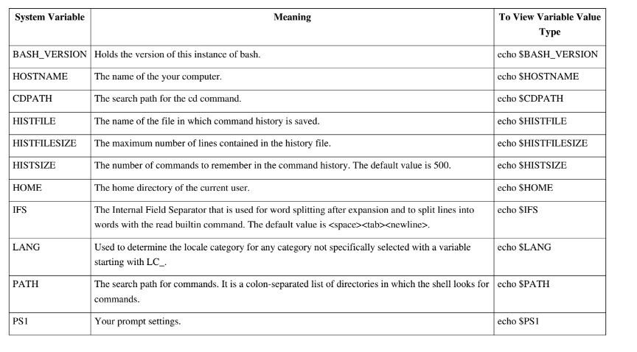

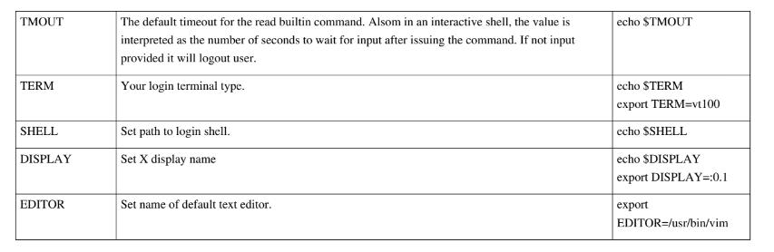

**To see the value of variables we type**

Echo “$PATH” we need to write $ in front of the variable name the variable name can also be highlighted by using { … }

To set default values to variables we use :=

All user defined variables are local and so go away when we start a new instance, so intsead we can make them global using *export -p*

To delete variables we use *unset variable name*

**To print we use** *echo or printf(works like c)*

**To compile a C file** we use gcc -c file.c -o name.o *to compile c programs*

**To link 2 files together** gcc YourAssemblyFile.o YourMacroFile.o -o YourExecutable

**Running a file for nexus a7,**

Use *make* inside the directory containing .s file.

Then use make clean to clear old .bin files

Then we need to send it to the board

Inside the directory ~/VEGA/vega-tools/utils/eth_transfer

./send.sh ~ /file.bin riscv.dtb

**To get to portal of board**

Cd -

Dmesg

Minicom -D /dev/tty

Minicom -D /dev/ttyUSB1

**Symbols used:**

